

*Accelerator Pack Audit*

Table of Contents

Overview 3

Application After Provisioning Rule 3

Workflow After Provisioning Step 3

Audit Events 4

Enable/Disable Audits 6

Accelerator Pack Audit Event Attributes 7

**Document Revision History**

|  |  |  |  |  |
| --- | --- | --- | --- | --- |
| **Version** | **Date** | **Status** | **Author** | **Summary of Changes** |
| Version 1 | 3/2/18 |  | Rohit Gupta | Initial Draft |
| Version 2 | 5/2/18 |  | Cathy Mallet | Minor edits |

# Overview

The purpose of this document is to explain the additional audit events that are added to Accelerator Pack for all provisioning actions on an application.

# Application After Provisioning Rule

All applications must have an after provisioning rule, “Rule-Audit-Framework”, to enable Accelerator Pack auditing. This rule can be saved from the IdentityIQ Application Administrative Wizard, or during application onboarding it is saved automatically from the Self Service Onboarding Wizard. This rule calls the Java method “**logRoadAuditEvents**” to log all provisioning events.

The New Account Entitlements Dependency Feature is enabled on an application via an after-provisioning rule called “Rule-AccountCreation-Dependency-Framework”. This rule provisions dependency application entitlements. A “**logRoadAuditEvents”** Java method has been added to this rule to ensure that Accelerator Pack audits are logged after the provisioning of dependency entitlements.

# Workflow After Provisioning Step

All Accelerator Pack workflows start from a wrapper workflow named “Workflow-FrameWork-Wrapper”. An After Provisioning Step is added to this workflow that calls the “**logRoadAuditEvents** Java method to audit following the provisioning items. These provisioning items doesn’t invoke the out-of-the-box After Provisioning rule on an application. As a result, this workflow step is required.

* Manual work items provisioning
* IdentityIQ internal request provisioning (for example, Roles)
* Ticket integration-based applications provisioning

# Audit Events

There are nine new audit events that have been added to Accelerator Pack to capture all provisioning actions. Wee the table below for the description of these new audit events.

**Note:** One Audit Event will be logged for every account request that is part of a provisioning plan.

|  |  |  |
| --- | --- | --- |
| Audit Name | Audit Display Name | Description |
| roadLifeCycleEventRequest | Accelerator Pack LifeCycle Event | This is used for all Accelerator Pack LifeCycle Events   * JOINER FEATURE * JOINER REHIRE FEATURE * JOINER LOA FEATURE * JOINER LTD FEATURE * LEAVER LOA FEATURE * LEAVER FEATURE * LEAVER LTD FEATURE * REVERSE LEAVER FEATURE * ATTRIBUTE SYNCHRONIZATION FEATURE * MANAGER CERTIFICATION ALLOW EXCEPTION FEATURE * NATIVE CHANGE DETECTION FEATURE * SER LINK FEATURE |
| roadCertificationLifeCycleEventRequest | Accelerator Pack LifeCycle Certification Event | This is used for Mover and Native Change Feature Certification Events |
| roadInteractiveRequest |  | This is used for request coming from QuickLinks and Interactive Pages  **QuickLinks**   * Manage User Access * Manage Privileged Access * Create Identity   + This kicks off Joiner Event for new Identity * Edit Identity   + This kicks off Attribute Sync Event for changed Identity * Register Identity * Change Password * Manage Passwords   **Interactive Pages**   * Batch Requests * Forgot Password * Password Expired Login |
| roadOperationalRequest | Accelerator Pack Operational Requests | This is used for requests originated from Operational Task QuickLink   * Terminate Identity * Process Identity Event * Recover Identity Access |
| roadBackGroundServiceRequest | Accelerator Pack Background Service Requests | This is used for requests coming from background services or tasks   * Password Interceptor * Privileged Service Account Password Expiration * Removal of Form Based Role * Reassignment of Service Owners to their Managers * X days Pending Leaver Requests * “Extended Form” application request   + Form Based Role applications that doesn’t have provisioning channel for certain form fields on the form |
| roadRoleEntitlementAssignmentsRequest | Accelerator Pack Automated Assignment Event | This audit event is for the RBAC Roles that are assigned via Assignment Rules  **Please Note:** This is not applied to applications that require tickets for provisioning |
| roadPolicyViolationDeprovisioningRequest | Accelerator Pack Policy Violation Requests | This audit event is for revoke actions on policy violations  **Please Note:** This is not applied to applications that require tickets for provisioning |
| roadCertificationRemediation | Accelerator Pack Certification Revocation Requests | This audit event is for the revoke action on the certification items.  **Please Note:** This is not applied to applications that require tickets for provisioning |
| roadWebservicesRequest | Accelerator Pack Web services Request | This audit event is for the request coming external applications to IdentityIQ via REST/SCIM.  **Please Note:** This is only applicable to “Workflow-FrameWork-Wrapper” workflow invocation via SCIM/REST Api and “requestType” argument value “EXTERNAL FEATURE” is passed to the workflow |

# Enable/Disable Audits

These new Accelerator Pack audits can be enabled/disabled from the out-of-the-box Global Settings / Audit Configuration Page.

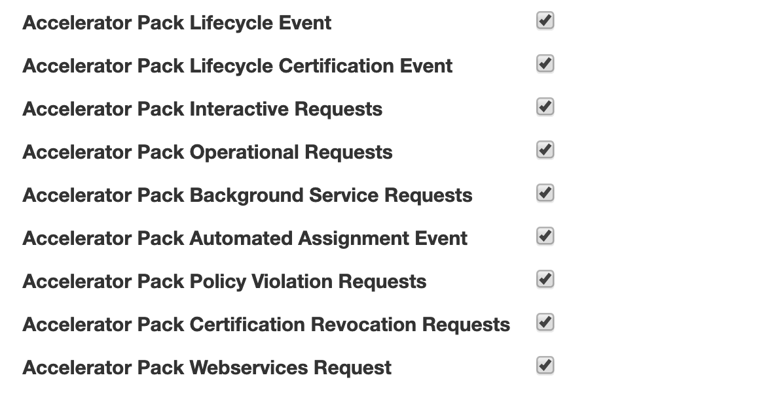

# Accelerator Pack Audit Event Attributes

Please see the table below for Audit Event attributes and their possible values.

|  |  |
| --- | --- |
| Audit Attribute Name | Description |
| Source | The value of this attribute will either be the requestor name for Interactive Requests, or “Scheduler” or “RequestHandler” for background events |
| Action | Display Name of the Audit Event |
| Account Name | Native Id from the Account Request |
| Target | Identity Name |
| Attributes | * **CertificatioName**: The name of the certification * **Operation**: Account Request Operation * **csvAttributeRequests**: All Attribute Requests (Operation, Name, and Value) * **csvErrors**: All Errors from Provisioning Plan, Account Request, and Attribute Request * **csvWarnings**: All Warnings from Provisioning Plan, Account Request, and Attribute Request * **csvTicketIds**: All Ticket Ids from Provisioning Plan, Account Request, and Attribute Request * **csvStatuses**: All Provisioning Statuses from Provisioning Plan, Account Request, and Attribute Request * **Error**: Errorfrom provisioning plan * **Flow**   + **AccessRequest** (Manage User Access or Manage Privileged Access or Batch Request)   + **AccountsRequest** (Manage Accounts)   + **ExpirePassword** (Password Expiration Login)   + **ForgotPassword** (Forgot Password)   + **PasswordsRequest** (Change Password or Manage Passwords)   + **IdentityCreateRequest** (Create Identity)   + **IdentityEditRequest** (Edit Identity)   + **Registration** (New User Registration)   + **External (**External Api Request, only if Wrapper workflow is invoked and “requestType” argument value “EXTERNAL FEATURE” is passed to the workflow)   + **Lifecycle** (All LifeCycle Events)   + **NewAccountDependency** (New Account Entitlements Provisioning)   + **FormRole** (Removal of Form Role)   + **LeaverXDays** (X Days Termination)   + **Recovery** (Operational Recovery Tool)   + **ServiceAccountOwners** (Service Account Owner Reassignment) * **Source**   + **Batch** (Batch Request)   + **LCM** (Access Request)   + **IdentityRefresh** (IdentityRefresh Assignments)   + **Rule** (Rule Assignments)   + **Certification** (Certification Revocation)   + **PolicyViolation** (Policy Violatin Remediations)   + **Task** (Back Ground Task) |
| Instance | requestType variable value from Workflow. List of possible values:   * JOINER FEATURE * JOINER REHIRE FEATURE * JOINER LOA FEATURE * JOINER LTD FEATURE * LEAVER LOA FEATURE * LEAVER FEATURE * LEAVER LTD FEATURE * REVERSE LEAVER FEATURE * ATTRIBUTE SYNCHRONIZATION FEATURE * MANAGER CERTIFICATION ALLOW EXCEPTION FEATURE * NATIVE CHANGE DETECTION FEATURE * SER LINK FEATURE * CART REQUEST FEATURE * MANAGE ACCOUNTS FEATURE * CREATE IDENTITY FEATURE * EDIT IDENTITY FEATURE * CHANGE PASSWORD FEATURE * REGISTRATION FEATURE * SER UNLINK FEATURE * RECOVERY TOOL FEATURE * IMMEDIATE TERMINATION FEATURE * PASSWORD INTERCEPTOR FEATURE * PRIVILEGED SERVICE PASSWORD EXPIRATION FEATURE * REQUEST MANAGER FEATURE * EXTERNAL FEATURE * MOVER FEATURE |
| Interface | Random Id to tie all provisioning plans of a provisioning project.  It will be empty if the audit event is logged from the after provisioning rule |
| Value 1 | Target Integration from the Provisioning Plan. Here are some samples:   * Target Integration:ServiceNowTicketIntegration * Target Integration:Active Directory * Target Integration: IIQ |
| Value 2 | Status from Provisioning Plan |
| Value 3 | Provisioning Plan Ticket Id |
| Value 4 | IdentityIQ Request Id |